**Thursday, April 10, 2025**

FOR IMMEDIATE RELEASE

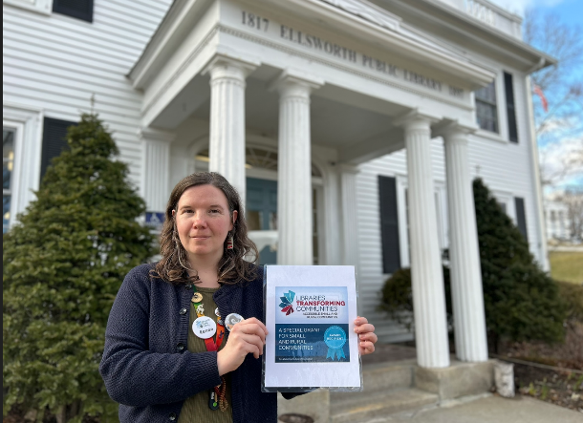**ELLSWORTH PUBLIC LIBRARY RECEIVES COMPETITIVE NATIONAL   
GRANT FOR SMALL AND RURAL LIBRARIES TO IMPROVE ACCESSIBILITY**  
  
EPL Assistant Director Renee McManus is presenting the ALA Grant Award Recipient Badge

Ellsworth, Maine — The Ellsworth Public Library (EPL) has been selected as one of 300 libraries to participate in round three of “Libraries Transforming Communities: Accessible Small and Rural Communities”, an American Library Association (ALA) initiative that provides community engagement and accessibility resources to small and rural libraries to help them better serve people with disabilities.

The **competitive award includes a $10,000 grant, funded through private donations**, which will support the Ellsworth Public Library’s efforts to improve ADA-compliant accessibility. These improvements will help ensure that community members with mobility challenges can fully access and enjoy the library, its services, and community spaces. Enhancing accessibility was one of the top priorities identified in the library’s 2024 community survey and was also highlighted as a need by the Maine State Fire Marshal.  
  
The library will host a **public community event on Thursday, June 5, 2025, at 12 PM** to gather input on the community’s most important needs and ensure the grant funds are used as effectively as possible.  
  
Rain Perez, EPL Board of Trustees *“It is of the utmost importance to us that as a public library, we are truly available to our entire populace and that everyone not only feels welcomed but can easily access the space that we feel belongs to them."*

Since 2014, ALA’s Libraries Transforming Communities initiative has re-imagined the role libraries play in supporting communities. Libraries of all types have utilized free dialogue and deliberation training and resources to lead community and campus forums; take part in anti-violence activities; provide a space for residents to come together and discuss challenging topics; and have productive conversations with civic leaders, library trustees and staff.

*“Libraries Transforming Communities: Accessible Small and Rural Communities is an initiative of the American Library Association (ALA) in collaboration with the Association for Rural and Small Libraries (ARSL).”*

An **Ellsworth Public Library Card opens the door** toa collection of more than 46,000 in-house items including books, large print books, audiobooks, movies, music CDs, and a growing Library of Things. Patrons have access to 50 print publications, streaming and download services. The New York Times is available to patrons on public access computers or any personal device. Additionally, patrons can request books through statewide Interlibrary loan services and reserve free passes to many renowned Down East museums. All library programs are free and open to all. Through a partnership with the Ellsworth American, anyone using the library’s Wi-Fi connection is granted free access to ellsworthamerican.com. [www.ellsworthlibrary.net](http://www.ellsworth.lib.me.us/)  
 **Contact:**Berit Becker  
Communications Director  
Ellsworth Public Library  
[bbecker@ellsworthlibrary.net](mailto:bbecker@ellsworthlibrary.net)